***IMPACT OF AIR POLLUTION ON OUR LIVES***

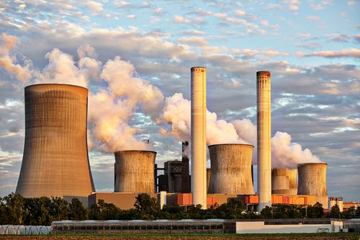

**GUTTI SUMANTH.**

**Data source:** [Central Pollution Control Board](http://cpcb.nic.in/) Sponsored by [Ministry of Environment and Forests, Govt of India](http://moef.nic.in/).

***Project notebook:*** https://github.com/sumanth13131/air-pollution-data-analysis/blob/master/Notebook.ipynb

Gmail: [sumanth13131@gmail.com](mailto:sumanth13131@gmail.com)

LinkedIn: <https://www.linkedin.com/in/sumanth18131a0363/>

Introduction

Air pollution has come up as a growing concern all over the world, especially in developing nations like India. India witnessed economic growth, rapid expansion of cities, industrialization, and fast-paced development of infrastructure since liberalization during the 1990s. Simultaneously, the level of air pollution in India has increased to a major health risk and cause of large premature mortality. Approximately one million people died in 2015 due to ambient particulate matter (PM) pollution alone in India. Indian cities have been always making into the top 20 most polluted cities of the world for the past few years and exceeding the ambient air quality standards recommended by the World Health Organization and Central Pollution Control Board (CPCB)

The spread of Coronavirus disease 2019 (COVID 19), which was initially identified in Wuhan of China, resulted in more than one million cases worldwide within the first four months. This has resulted in lockdown in many nations worldwide. While, the first confirmed case in India was on January 30th, 2020, the first international travel advisory posing restrictions on travel to China, Republic of Korea, Iran, Italy and Japan was issued on March 11th of after the country saw sudden jump in COVID-19 cases on March 4th Southern state of India, Kerala, which was initially the most effected state imposed curtails on mass gatherings on March 10th. Starting from March 16th all places of mass gatherings such as institutions, shopping malls and theatres were closed across the country. The first nationwide lockdown for fourteen hours was on March 22nd, which was followed by 21 days lockdown starting from March 24th. This lockdown enforces restrictions and self-quarantine measures, which reduce emissions from transportation and industries. The changes in air pollution in this lockdown period can provide an insight into the achievability of air quality improvement when there are significant restrictions in emissions from many sources and gives regulators better plans to control air pollution.

In this paper we analysed the variations in ground-based air quality and meteorological data obtained from a network of air quality monitoring stations across 22 different cities in India for the past four years (2017–2020) for the time period of March 16th to April 14th. Comparison of data in the last four years helps in understanding the potential effect of change in emissions during days with similar meteorology. This paper also explores the possible scenario which could result in national capital region if similar control on anthropogenic emissions occurs in worst meteorology conditions using Weather Research Forecasting (WRF)- Air Quality Dispersion Modelling System (AERMOD).

## Data

## This data is a cleaner version of the Historical Daily Ambient Air Quality Data released by the Ministry of Environment and Forests and Central Pollution Control Board of India under the National Data Sharing and Accessibility Policy (NDSAP). The dataset contains the following features:

1. **state**: It represents the states whose air quality data is measured.
2. **so2**: The amount of Sulphur Dioxide measured.
3. **no2**: The amount of Nitrogen Dioxide measured.
4. **pm2.5 & pm10**: It represents the value of particulate matter measured.

## Why these features?

**SO₂**: Sulphur Dioxide is a gas. It is one of the major pollutants present in the air.  
It is colourless and has a nasty, sharp smell.  
It combines effortlessly with other chemicals to form harmful substances like sulphuric acid, sulphurous acid, etc.  
Sulphur dioxide affects human health when it is inhaled. It irritates the nose, throat, and airways to cause **coughing, wheezing, shortness of breath**, or a tight feeling around the chest. Those most at risk of developing problems if they are exposed to sulphur dioxide are people with asthma or similar conditions. Also, the concentration of sulphur dioxide in the atmosphere can influence the**habitat suitability** for plant communities, as well as animal life.  
Inhaling sulphur dioxide is associated with increased respiratory symptoms and disease, **difficulty in breathing**, and **premature death**.  
It also causes**acid rain**.

**NO₂**: Nitrogen Dioxide is a reddish-brown gas with a pungent, acrid odour.  
It can cause **bronchoconstriction, inflammation, reduced immune response**, and may have effects on the heart. Direct exposure to the skin can cause irritations and **burns**.  
The following gives a rough idea of nitrogen dioxide’s impact on health :  
10–20 ppm can cause mild irritation of the **nose** and **throat**  
25–50 ppm can cause oedema leading to **bronchitis** or**pneumonia**  
Levels above 100 ppm can cause **death** due to asphyxiation from fluid in the lungs.  
High levels of NO₂ can harm **vegetation**, including leaf damage and reduced growth. It can make vegetation more susceptible to **disease** and **frost damage**.  
Longer exposures to elevated concentrations of NO₂ may contribute to the development of **asthma** and potentially increase susceptibility to respiratory infections.

**Particulates:**These are also known as Atmospheric aerosol particles, atmospheric particulate matter, particulate matter (PM) or suspended particulate matter (SPM).These are microscopic solid or liquid matter suspended in the atmosphere.  
**Particulates are the deadliest form of air pollution**due to their ability to penetrate deep into the lungs and bloodstreams unfiltered, causing permanent **DNA mutations**, **heart attacks, respiratory disease**, and **premature death**.  
Worldwide exposure to PM 2.5 contributed to **4.1 million** deaths from heart disease and stroke, lung cancer, chronic lung disease, and respiratory infections in 2016. Overall, ambient particulate matter ranks as the sixth leading risk factor for premature death globally. The internet is filled with the harmful effects of the above pollutants, and hence it makes them an essential factor to be analysed and considered when discussing air pollution.

**Change in concentrations of pollutants**

Shows the temporal change in the average concentrations of the six criteria pollutants in the five regions. Overall, around 43, 31, 10, and 18% decreases in PM2.5, PM10, CO, and NO2 were observed during lockdown period compared to the previous years. While there were 17% increase in O3 and negligible change in SO2. The higher decrease in PM10 compared to PM2.5 could be due to its greater contribution from anthropogenic sources

Significant decreases in concentrations of PM2.5, PM10, NO and NO2 were observed in north India. For example, compared to an average decrease of 12% in the previous years, PM2.5 concentration in 2020 decreased by 34%, clearly indicating the effect of lockdown. Similar conclusions can be derived for PM2.5 and PM10 in other regions. A slight increase in SO2 concentrations was observed in 2020 compared to previous year. This could be due to no restrictions on power plants in northern India and using coal powered energy an essential commodity during lockdown period. A decrease in O3 was observed in 2020 compared to 2019, while compared to last three years averagely, the concentrations in 2020 were 10% higher.

In east India, while there was a decrease in CO concentration, an increase in other gaseous pollutants was observed in 2020 compared to 2019. O3 had 77% increase compared to 2019 and 89% increase compared to the average concentration in 2017 to 2019. In southern India, clear decrease in NO, NO2 and O3 was observed during the lockdown period, while increase in CO was observed. Increases in O3 and CO and decreases in NO and NO2 were observed in central India. Most cities in northern, western and southern regions are VOC limited , thus this increase in O3 could be due to more decrease in NOx compared to VOC. Furthermore, this could also be attributed to decrease in PM concentrations, which can result in more sunlight passing through atmosphere encouraging more photochemical activities and thus higher O3 production.

# **DATA VISUALIZATION**

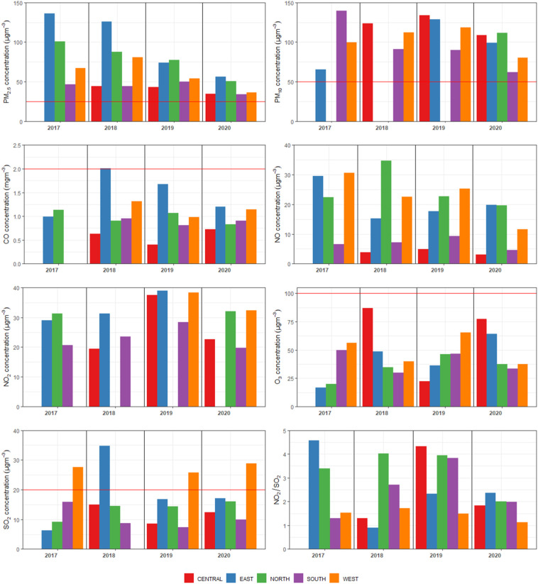

**In 2016 average concentration state wise in India:**

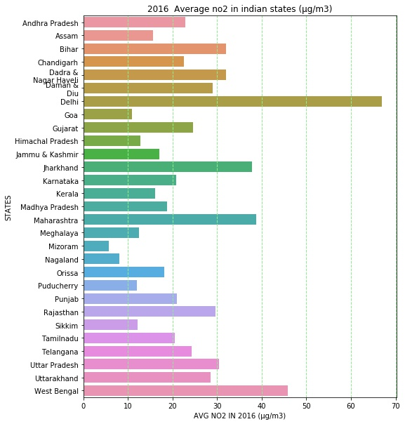

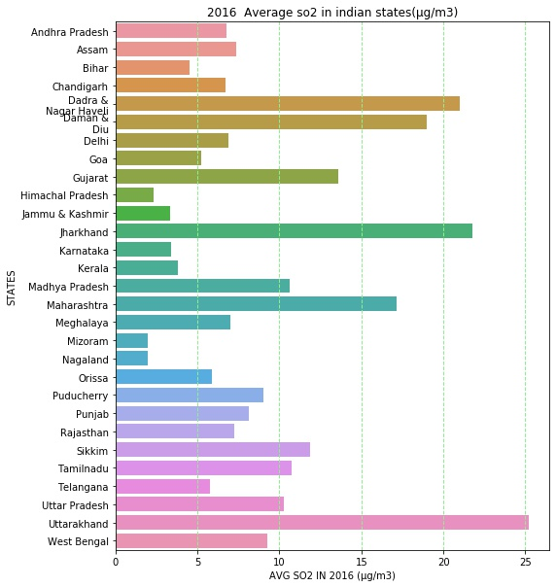

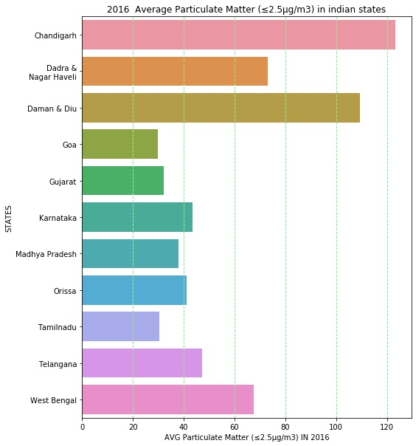

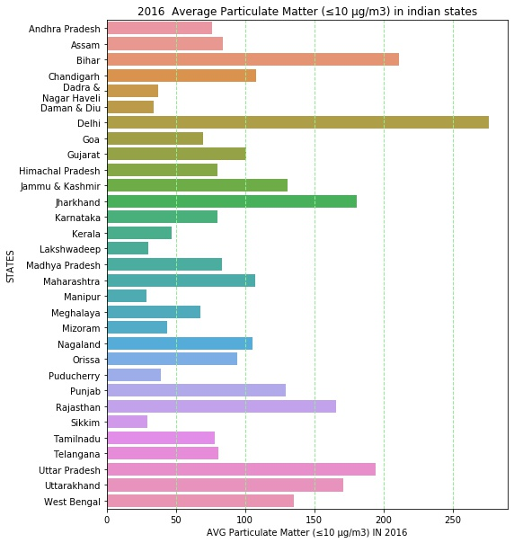

**In 2017 average concentration state wise in India:**

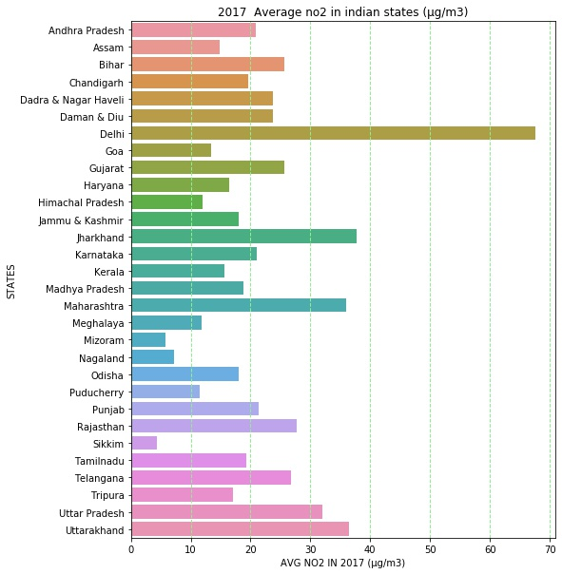

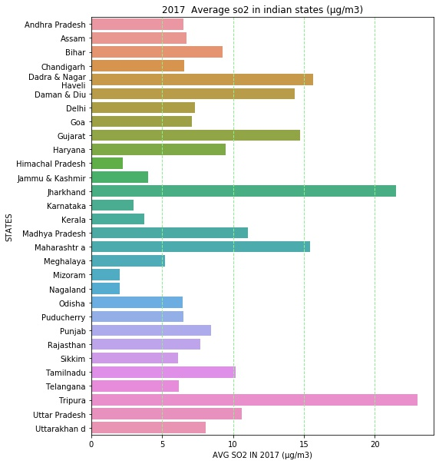

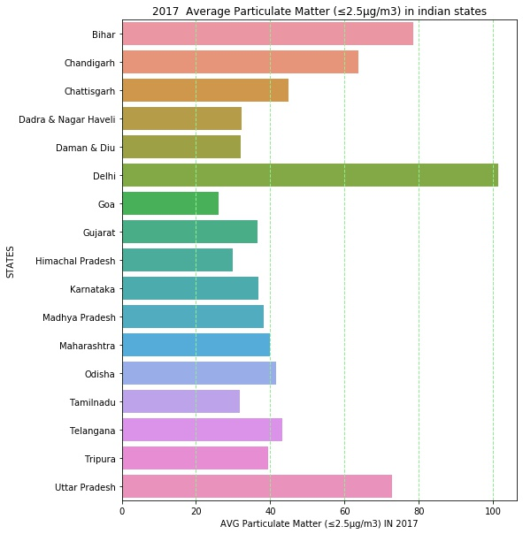

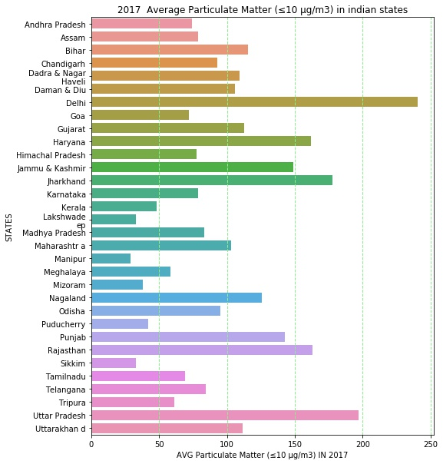

**In 2018 average concentration state wise in India:**

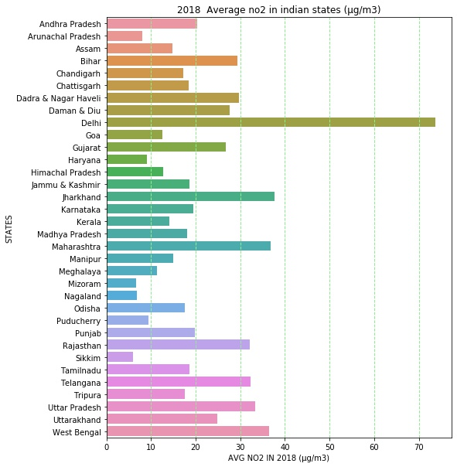

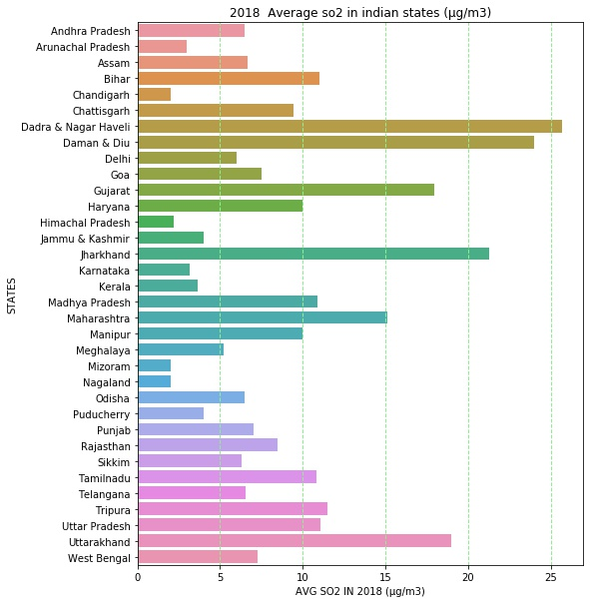

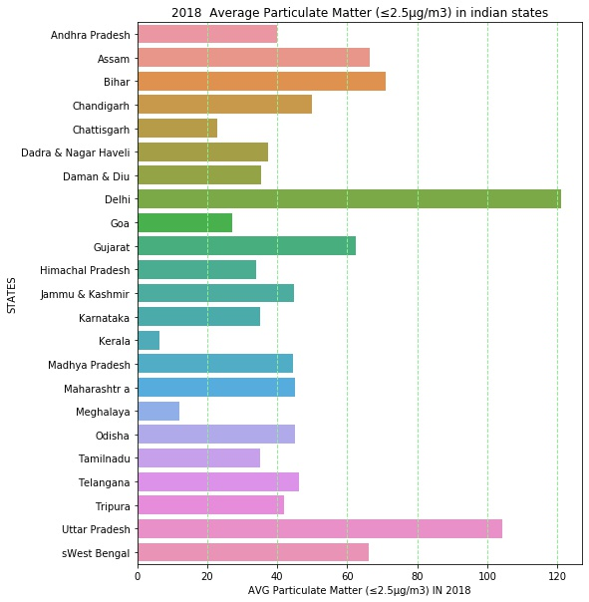

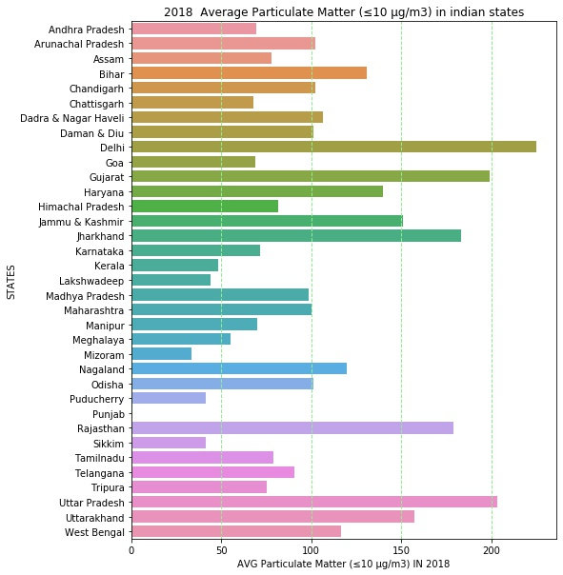

**For a more in-depth analysis, let us look at the correlation:**

**2016:**

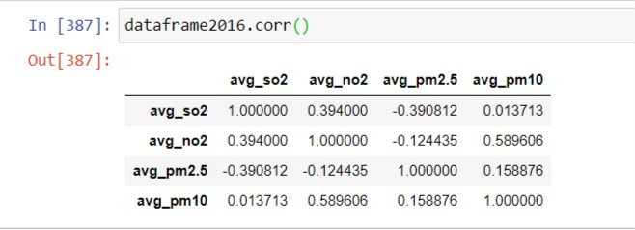

**2017:**

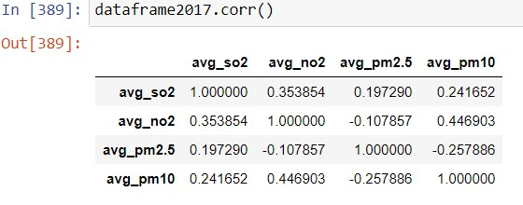

**2018:**

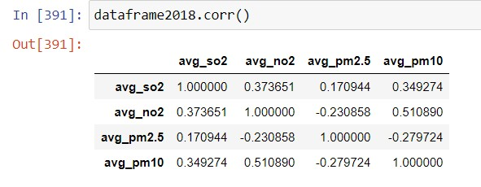

**According to social media and news reports:**

**Trend of pollutants:**

**SO2**

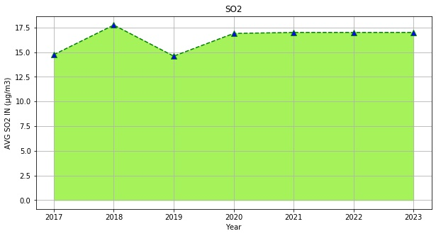

**NO2**

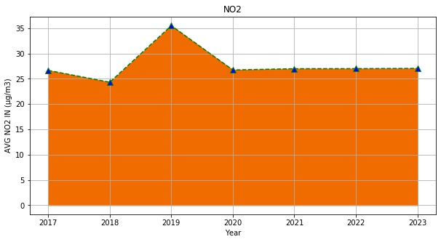

**PM2.5**

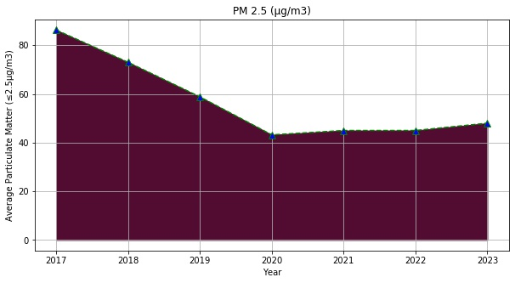

**PM10**

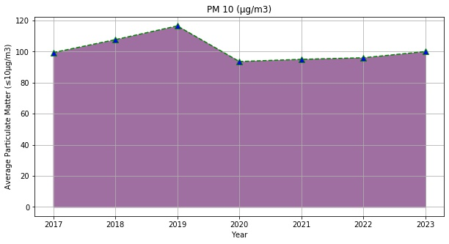

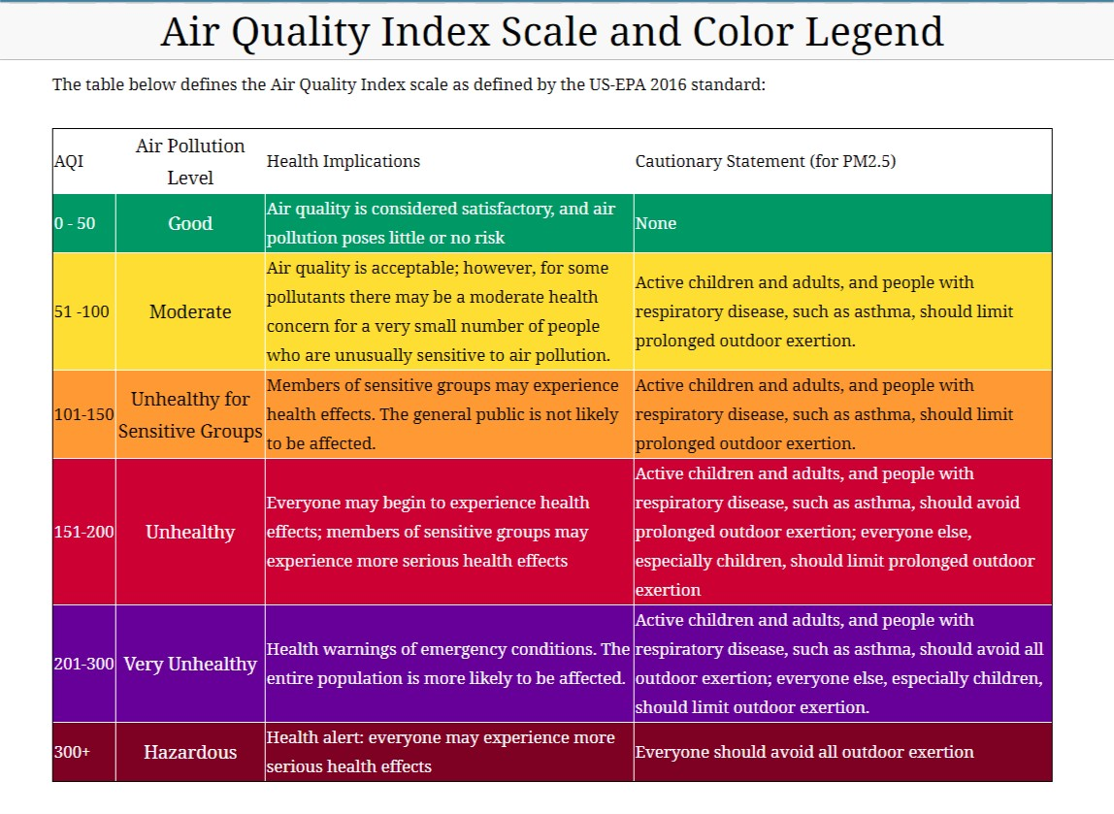

**Summary:**

From the above analysis, we see that the majorly affected states in India by air pollution belong to the northern region.  
States like Delhi, Punjab, Uttar Pradesh, Haryana are heavily polluted and require immediate action.  
We also saw that even if a state had a high level of pollutants, there were some regions in the states that were not polluted.

The effect of restricted human activities due to the COVID-19 pandemic in India since mid-March of 2020 was studied by analysing concentrations of six criteria pollutants during March 16th to April 14th from 2017 to 2020 in 22 cities covering different regions. Among all pollutants, PM2.5 had maximum reduction in most regions. In contrary, in most regions an increase in O3 was observed, which could be due to the decrease in PM in addition to decrease in NOx. This substantial reduction in concentrations resulted in a 4 times reduction in ER. As expected, a significant reduction in AQI was observed in 2020 compared to previous years. However, four cities had O3 as their dominant pollutant instead of PM2.5, suggesting that attention should also be given to decreasing emissions of precursors to secondary pollutants in addition to controlling primary PM. Correlation between cities especially in northern and eastern regions improved in 2020 compared to previous years, indicating more significant regional transport than previous years. Further analysis on actual and unfavourable meteorology using WRF-AERMOD modelling system concluded that even the predicted PM2.5 could increase due to unfavourable meteorology, the average concentration would still be under CPCB limits. This study gives confidence to the regulatory bodies that a significant improvement in air quality in India could be expected if strict execution of air quality control plans is implemented.

---------------------------Thank q -----------------------------